Trial Balance Application

## Instructions

Instructions for “Trial Balance Application”

**Please read and follow all the instructions for a proper use of the application!**

## Pre-requisites:

**Current Year Trial Balance**

* For the current year Trial Balance file, the following header should be used:

|  |  |  |
| --- | --- | --- |
| **Header name** | **Format** | **Example** |
| Account | General / Text | “101100” |
| Description | General / Text | “CAPITAL SOCIAL SUBSCRIS NEVARSAT” |
| SID | General / Number | 39,000 |
| SIC | General / Number | 39,000 |
| RCD | General / Number | 39,000 |
| RCC | General/Number | 39,000 |
| SFD | General / Number | 39,000 |
| SFC | General / Number | 39,000 |

**\*\*Note:** Where SID & SIC are “Sold Initial Debit” & “Sold Initial Credit”, RCD & RCC are “Rulaj Curent Debit” & “Rulaj Curent Credit” and SFD & SFC are “Sold Final Debit” & “Sold Final Credit”.

**Prior Year Trial Balance (Not Mandatory)**

* For the prior year Trial Balance file, the following header should be used:

|  |  |  |
| --- | --- | --- |
| **Header name** | **Format** | **Example** |
| Account | General / Text | “101100” |
| Description | General / Text | “CAPITAL SOCIAL SUBSCRIS NEVARSAT” |
| SFD | General / Number | 39,000 |
| SFC | General / Number | 39,000 |
| CB | General/Number | 39,000 |

**\*\*Note**: Where CB stands for Closing Balance.

**Mapping file Template:**

* The user should select one of the two mappings inbedded below:

********

## Instructions:

1. After connecting to the platform, go to **Trial Balances**:

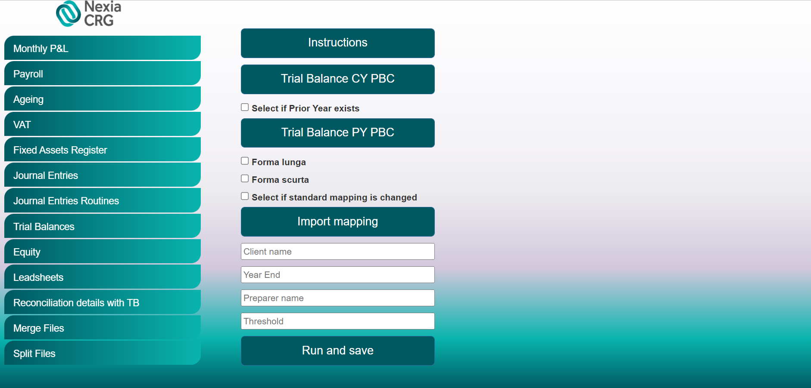

1. Click the “Trial Balance CY PBC” button and import the Current Year Trial Balance
2. If prior year Trial Balance is available, tick the “*Select if Prior Year exists*” and import the template by click the “Trial Balance PY PBC” button.
3. Tick “*Forma Lunga*” or “*Forma Scurta*”, based on the mapping selected.
4. Click the “Import mapping” button and select the mapping file.
5. Insert the Client name, the period end (MM/DD/YYYY) of the audit (Year End), Preparer Name and Threshold.
6. Click “Run and save”. Once clicking that, the robot will process your request and download the file in your designated downloads folder.
7. Finally, you should obtain an Excel document named “Trial Balance”.

For any issues, questions and/ or suggestions, please contact:

Cristian Iordache, [cristian.iordache@ro.gt.com](mailto:cristian.iordache@ro.gt.com)

Bogdan Constantinescu, [bogdan.constantinescu@ro.gt.com](mailto:bogdan.constantinescu@ro.gt.com)